EMCH 260 HW3

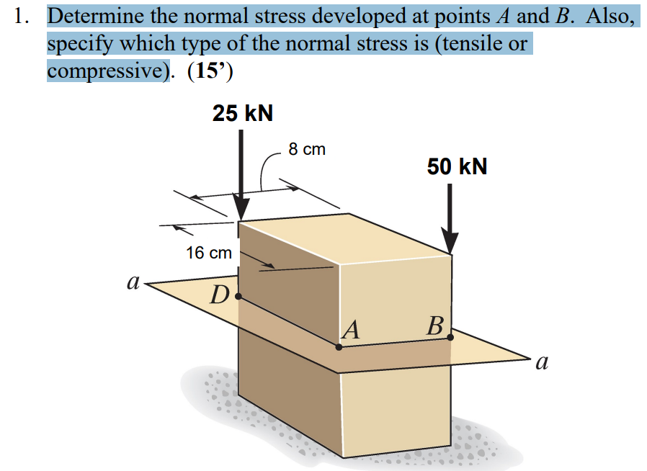
$$∑F_{z}=-25kN-50kN=-75kN$$
$$∑M_{y}=0.04*\left(25kN-50kN\right)=-1kN*m$$
$$∑M_{x}=0.08*\left(50kN-25kN\right)=2kN*m$$
$$A=0.08*0.16=0.0128m^{2}$$
$$I_{y}=\frac{1}{12}bh^{3}=\frac{1}{12}*0.16*{0.08}^{3}=\frac{8}{1171875}$$
$$I_{x}=\frac{1}{12}hb^{3}=\frac{1}{12}*0.08*{0.16}^{3}=\frac{32}{1171875}$$
$$σ_{x Max}=\frac{M_{x}c_{y}}{I_{x}}=\frac{2000*0.08}{\frac{32}{1171875}}=5859375$$

$$σ_{y Max}=\frac{M_{y}c_{x}}{I_{y}}=\frac{1000*0.04}{\frac{8}{1171875}}=5859375$$
$$σ_{A}=\frac{F}{A}+σ_{y Max}+σ_{x Max}=-\frac{75kN}{0.0128}+5859375+5859375=+5859375→Tension$$
$$σ_{B}=\frac{F}{A}-σ_{y Max}-σ_{x Max}=-\frac{75kN}{0.0128}-5859375-5859375=-17578125→Compression$$
$$σ_{C}=\frac{F}{A}-σ_{y Max}+σ_{x Max}=-5859375→Compression$$
$$σ_{D}=\frac{F}{A}+σ_{y Max}-σ_{x Max}=-5859375→Compression$$

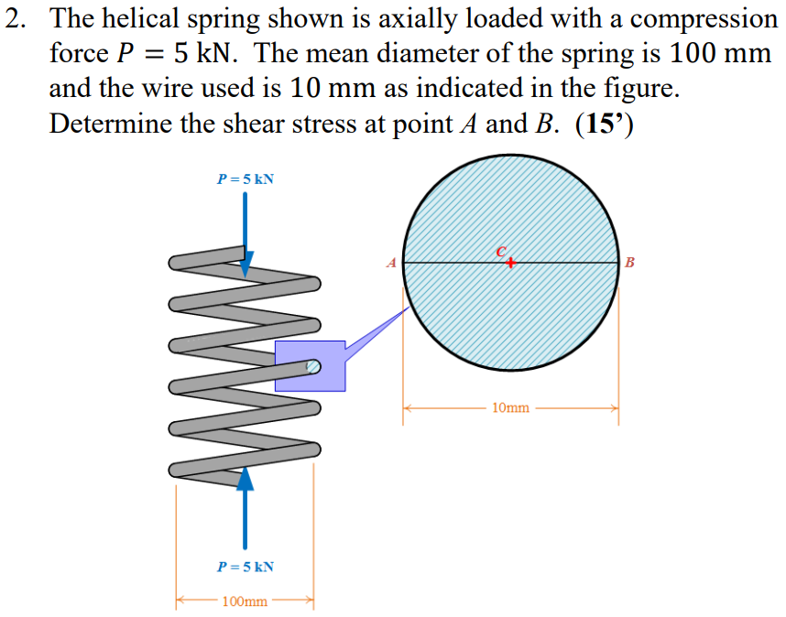
$$T=0.05P=0.25kN*m$$
$$τ1=\frac{P}{A}=\frac{5kN}{π*5^{2}}=63.66MPa$$
$$τ2=\frac{Tr}{J}=250Nm*5kN=1273.24MPa$$
$$τA=τ1+τ2 = 63.66+1273.24 = 1336.9 MPa$$
$$τB=τ2-τ1$$
$$1273.24-63.66=1209.54$$

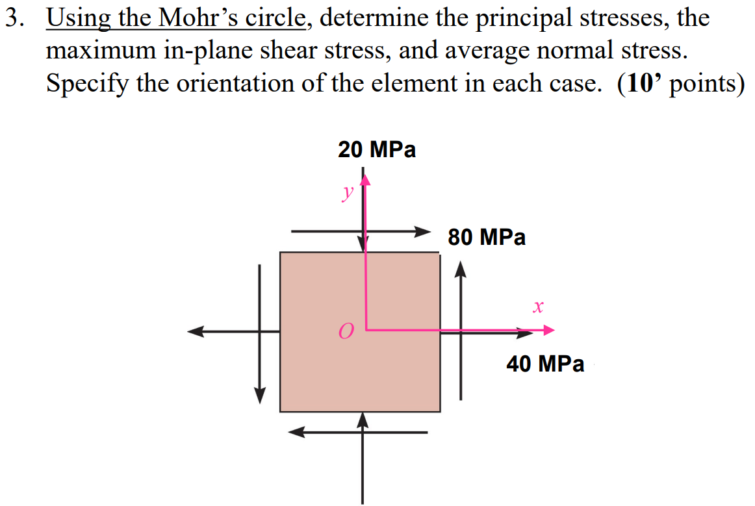
$$σx=40MPa$$
$$σy=-20 MPa$$
$$τxy=80MPa$$
$$σavg=\frac{-20+40}{2}=10MPa average normal stress$$
$$C=\left(10MPa, 0\right)$$
$$R=\sqrt{{\left(\frac{40-\left(-20\right)}{2}MPa\right)}^{2}+80MPa^{2}}=85.44 MPa Max in-plane shear stress$$
$$σ1=10+85.44=95.44 principal stress$$
$$σ2=10-85.44=-75.44 principal stress$$
$$2θp=\tan^{-1}\left(\frac{80}{30}\right)=69.44°→θp=34.722°$$
$$2θs=69.44+90=159.44°→θ=79.72°$$

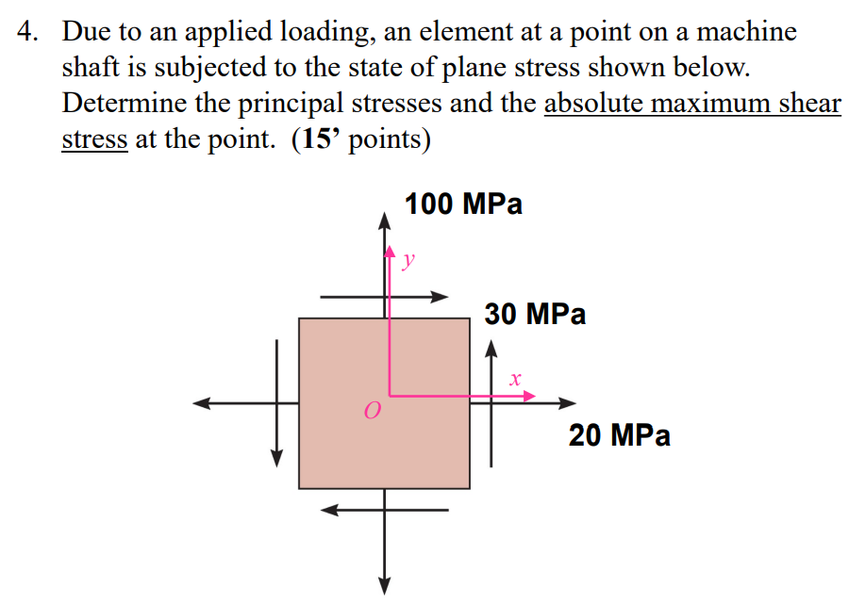
$$σx=20MPa$$
$$σy=100 MPa$$
$$τxy=30MPa$$
$$σavg=\frac{20+100}{2}=60MPa avergae normal stress$$
$$C=\left(60MPa, 0\right)$$
$$R=\sqrt{{\left(\frac{20-100}{2}MPa\right)}^{2}+30MPa^{2}}=50 MPa Max in-plane shear stress$$
$$σ1=60+50=110 principal stress$$
$$σ2=60-50=-10 principal stress$$
$$τ abs Max=\frac{110-\left(-10\right)}{2}=60MPa$$

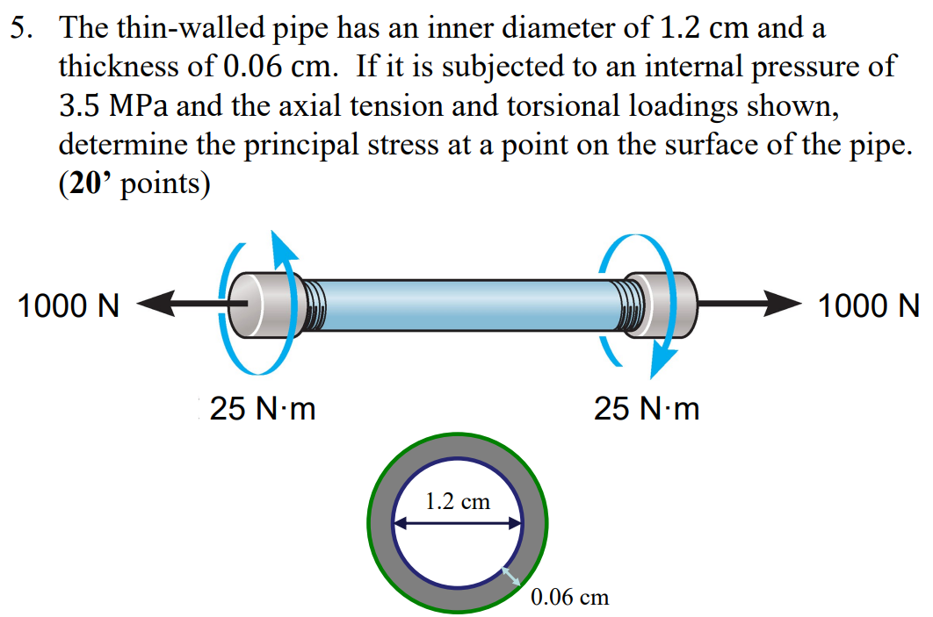

$$axial tension σ_{axial}=\frac{P1*r}{2t}=\frac{3500000*0.006}{2*0.0006}=17.5 MPa$$
$$hoop tension σy=\frac{P1*r}{t}=\frac{3500000*0.006}{0.0006}=35MPa$$
$$τxy=\frac{Tc}{J}=\frac{25*0.66}{\frac{π}{2}\left({0.0066}^{2}-{0.006}^{2}\right)}=1.389MPa$$
$$σx=σ_{axial}+\frac{N}{A}=\frac{1000}{π\left({0.0066}^{2}-{0.006}^{2}\right)}+17.5=59.6MPa$$
$$σavg=\frac{σx+σy}{2}=\frac{35+59.6}{2}=47.3MPa$$
$$R=\sqrt{{\left(\frac{σx-σy}{2}\right)}^{2}+τ^{2}}=\sqrt{{\left(\frac{59.6-35}{2}\right)}^{2}+{1.389}^{2}}=12.378MPa$$
$$C=(47.3,0)$$
$$σ1=47.3+12.378=59.678$$
$$σ2=47.3-12.378=34.922$$
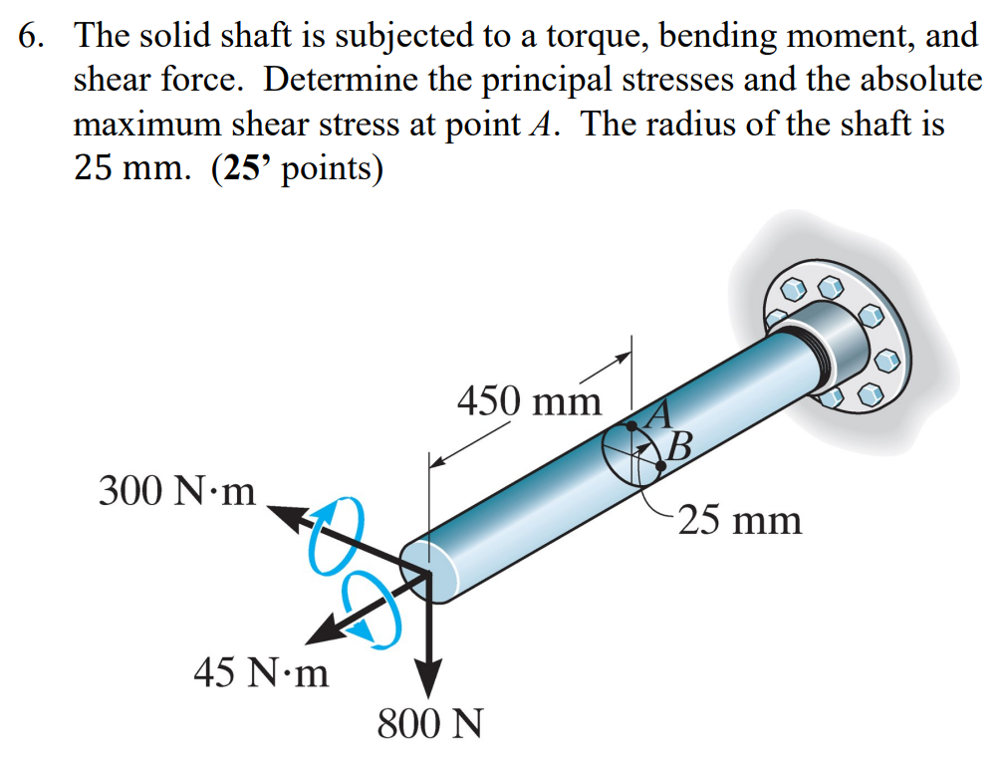
$$Mz=800*0.45-300=60N*m$$
$$Tx=45 N*m$$
$$J=\frac{π}{2}r^{4}=\frac{π}{2}*{0.025}^{4}$$
$$Ix=Iy=\frac{π}{4}r^{4}=\frac{π}{4}*{0.025}^{4}$$

$$σx=\frac{Mz*\overline{y}}{Ix}=\frac{60*0.025}{\frac{π}{4}*{0.025}^{4}}=\frac{15360000}{π}Pa$$
$$τxz=-\frac{Tx*r}{J}=-\frac{45*0.025}{\frac{π}{2}*{0.025}^{4}}=-\frac{5760000}{π}Pa$$
$$σavg=\frac{σx+σz}{2}=\frac{\frac{15360000}{π}+0}{2}=\frac{7680000}{π}Pa$$
$$R=\sqrt{{\left(σx-σavg\right)}^{2}+{\left(τxz\right)}^{2}}=\sqrt{{\left(\frac{7680000}{π}\right)}^{2}+{\left(-\frac{5760000}{π}\right)}^{2}}=\frac{9600000}{π} Pa$$
$$σ1=σavg+R=\frac{7680000}{π}+\frac{9600000}{π}=\frac{17280000}{π}Pa=5.5MPa$$
$$σ2=σavg-R=\frac{7680000}{π}-\frac{9600000}{π}=-\frac{1920000}{π}Pa=-0.611MPa$$
$$τmax=\frac{σ1-σ2}{2}=\frac{\frac{17280000}{π}-(-\frac{1920000}{π})}{2}=\frac{9600000}{π}Pa=3.05577MPa$$

